**LAB ASSIGNMENT – 2**

**Grihit Budhiraja**

**19BCE2141**

**Checksum**

**Code –**

#include<stdio.h>

#include<conio.h>

#include <cstdlib>

int add(int,int);

int com(int);

void receiver(int data1[],int data2[],int checksum[], int newdata[], int dl);

void modify(int data1[],int data2[],int checksum[], int newdata[], int dl);

void sender()

{

int i,dl,dil,choice;

int data1[10],data2[10],newdata[10],checksum[10];

printf("\n Enter the data length: ");

scanf("%d",&dl);

printf("\n Enter the data1: ");

for(i=0;i<dl;i++)

scanf("%d",&data1[i]);

printf("\n Enter the data2: ");

for(i=0;i<dl;i++)

scanf("%d",&data2[i]);

for(i=dl-1;i>=0;i--)

{

newdata[i]=add(data1[i],data2[i]);

}

printf("\n\n Data 1: ");

for(i=0;i<dl;i++)

printf("%d",data1[i]);

printf("\n Data 2: ");

for(i=0;i<dl;i++)

printf("%d",data2[i]);

printf("\n\n The new data is : ");

for(i=0;i<dl;i++)

{

printf("%d",newdata[i]);

}

printf("\n Checksum : ");

for(i=0;i<dl;i++)

{

checksum[i]=com(newdata[i]);

printf("%d",checksum[i]);

}

printf("\n Do you want to modify the message? Enter 1 for yes, 0 for no.\n");

scanf("%d",&choice);

if(choice)

modify(data1,data2,checksum, newdata, dl);

else

receiver(data1,data2,checksum, newdata, dl);

}

void receiver(int data1[],int data2[], int checksum[], int newdata[], int dl)

{

int i,comp[10],sum=0;

printf("\n\n Receiver Side : \n");

printf("\n Data : ");

for(i=0;i<dl;i++)

printf("%d",data1[i]);printf(" ");

for(i=0;i<dl;i++)

printf("%d",data2[i]);printf(" ");

for(i=0;i<dl;i++)

printf("%d",checksum[i]);

printf("\n After Addition : ");

for(i=dl-1;i>=0;i--)

{

newdata[i]=add(newdata[i],checksum[i]);

}

for(i=0;i<dl;i++)

{

printf("%d",newdata[i]);

}

printf("\n Compliment : ");

for(i=0;i<dl;i++)

{

comp[i]=com(newdata[i]);

printf("%d",comp[i]);

}

for(i=0;i<dl;i++)

{

sum=sum+comp[i];

}

if(sum==0)

printf("\n No error");

else

printf("\n Error");

}

void modify(int data1[], int data2[], int checksum[], int newdata[], int dl)

{

int rnd = (rand() % dl);

if (data1[rnd] == 0)

{

data1[rnd] = 1;

}

else

{

data1[rnd] = 0;

}

receiver(data1,data2,checksum, newdata, dl);

}

int main()

{

sender();

return 0;

}

int add(int x, int y)

{

static int carry=0;

if(x==1 && y==1 && carry==0)

{

carry=1;

return 0;

}

else if(x==1 && y==1 && carry==1)

{

carry=1;

return 1;

}

else if(x==1 && y==0 && carry==0)

{

carry=0;

return 1;

}

else if(x==1 && y==0 && carry==1)

{

carry=1;

return 0;

}

else if(x==0 && y==1 && carry==0)

{

carry=0;

return 1;

}

else if(x==0 && y==1 && carry==1)

{

carry=1;

return 0;

}

else if(x==0 && y==0 && carry==0)

{

carry=0;

return 0;

}

else

{

carry=0;

return 1;

}

}

int com(int a)

{

if(a==0)

return 1;

else

return 0;

}**Output –**

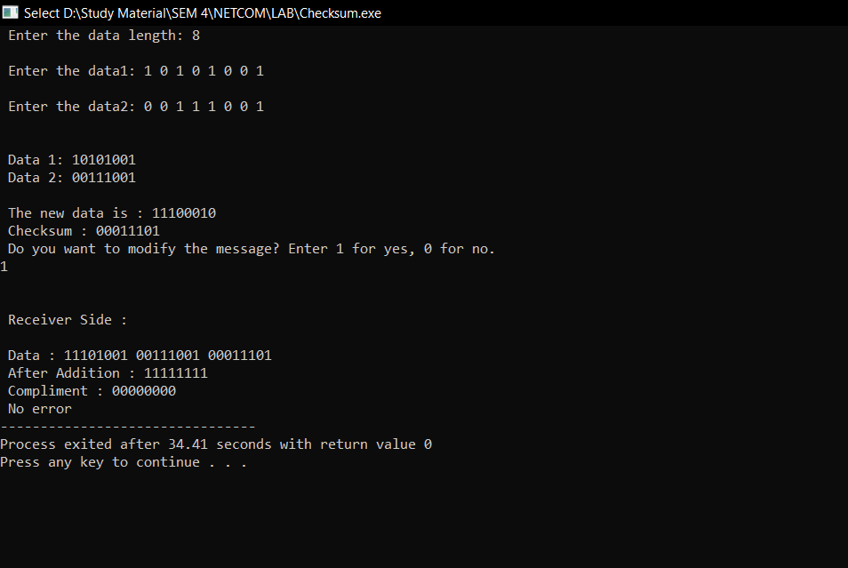

**CRC**

**Code –**

#include <iostream>

#include <cstdlib>

using namespace std;

void division(int temp[], int gen[], int size, int r)

{

for (int i = 0; i < size; i++)

{

if (gen[0] == temp[i])

{

for (int j = 0, k = i; j < r + 1; j++, k++)

if (!(temp[k] ^ gen[j]))

temp[k] = 0;

else

temp[k] = 1;

}

}

}

void receiver(int message[], int size, int r, int gen[])

{

int temp[50];

cout << endl<< endl<< "At Receiver's End " << endl;

cout << "The received message : ";

for (int i = 0; i < size + r; i++)

cout << message[i] << " ";

for (int i = 0; i < size + r; i++)

temp[i] = message[i];

division(temp, gen, size, r);

for (int i = 0; i < r; i++)

{

if (temp[size + i])

{

cout << "\nError detected in received message.";

return;

}

}

cout << "\nNo error in received Message.\nReceived Message : ";

for (int i = 0; i < size; i++)

cout << message[i] << " ";

}

int modify(int message[], int size, int r, int gen[])

{

int rnd = (rand() % size);

if (message[rnd] == 0)

{

message[rnd] = 1;

}

else

{

message[rnd] = 0;

}

receiver(message, size, r, gen);

}

void sender()

{

int size, r, message[50], gen[50], temp[50], choice = 0;

cout << "At Sender's End " << endl;

cout << "Enter the number of message bits : ";

cin >> size;

cout << "Enter the number of generator bits : ";

cin >> r;

cout << "Enter the message : ";

for (int i = 0; i < size; i++)

cin >> message[i];

cout << "Enter the generator : ";

for (int i = 0; i < r; i++)

cin >> gen[i];

r--;

for (int i = 0; i < r; i++)

message[size + i] = 0;

for (int i = 0; i < size + r; i++)

temp[i] = message[i];

division(temp, gen, size, r);

cout << "CRC : ";

for (int i = 0; i < r; i++)

{

cout << temp[size + i] << " ";

message[size + i] = temp[size + i];

}

cout <<endl<< "Transmitted Message : ";

for (int i = 0; i < size + r; i++)

cout << message[i] << " ";

cout << "\nDo you want to modify the message? enter 1 for yes, 0 for no. ";

cin >> choice;

if (choice)

{

modify(message, size, r, gen);

}

else

{

receiver(message, size, r, gen);

}

}

int main()

{

sender();

return 0;

}

**Output –**

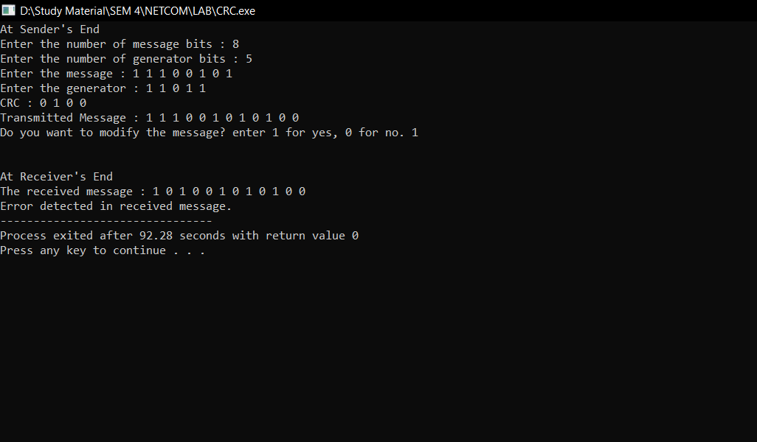

**Hamming Code**

**Code –**

#include <stdio.h>

#include <math.h>

int input[32];

int code[32];

int ham_calc(int,int);

void Receiver(int,int);

void sender()

{

int n,i,p_n = 0,c_l,j,k;

printf("Please enter the length of the Data Word: ");

scanf("%d",&n);

printf("Please enter the Data Word:\n");

for(i=0;i<n;i++)

{

scanf("%d",&input[i]);

}

i=0;

while(n>(int)pow(2,i)-(i+1))

{

p_n++;

i++;

}

c_l = p_n + n;

j=k=0;

for(i=0;i<c_l;i++)

{

if(i==((int)pow(2,k)-1))

{

code[i]=0;

k++;

}

else

{

code[i]=input[j];

j++;

}

}

for(i=0;i<p_n;i++)

{

int position = (int)pow(2,i);

int value = ham_calc(position,c_l);

code[position-1]=value;

}

printf("\nThe calculated Code Word is: ");

for(i=0;i<c_l;i++)

printf("%d",code[i]);

printf("\n");

Receiver( c_l, p_n);

}

void Receiver(int c_l, int p_n)

{

int i;

printf("Enter the received Code Word:\n");

for(i=0;i<c_l;i++)

scanf("%d",&code[i]);

int error_pos = 0;

for(i=0;i<p_n;i++)

{

int p = (int)pow(2,i);

int value = ham_calc(p,c_l);

if(value != 0)

error_pos+=p;

}

if(error_pos == 1)

printf("The received Code Word is correct.\n");

else

printf("Error at bit position: %d\n",error_pos);

}

int ham_calc(int p,int c_l)

{

int count=0,i,j;

i=p-1;

while(i<c_l)

{

for(j=i;j<i+p;j++)

{

if(code[j] == 1)

count++;

}

i=i+2*p;

}

if(count%2 == 0)

return 0;

else

return 1;

}

int main()

{

sender();

return 0;

}

**Output –**

